LAB # 03
Performing Arithmetic Operations using Microsoft Excel, Studying Advance Formulae

Introduction

Microsoft Excel has the basic features of all spreadsheets, using a grid of cells arranged in numbered rows and letter-named columns to organize data manipulations like arithmetic operations. It has a battery of supplied functions to answer statistical, engineering and financial needs. In addition, it can display data as line graphs, histograms and charts, and with a very limited three-dimensional graphical display. It allows sectioning of data to view its dependencies on various factors for different perspectives (using pivot tables and the scenario manager. It also has a variety of interactive features allowing user interfaces that can completely hide the spreadsheet from the user, so the spreadsheet presents itself as a so-called application, or decision support system (DSS).
Example #1 – How to Create Spreadsheet in Excel?
Step 1: Open MS Excel.
Step 2: Go to Menu and select New >> click on the Blank workbook to create a simple worksheet.
OR – Just press Ctrl + N: To create a new spreadsheet.
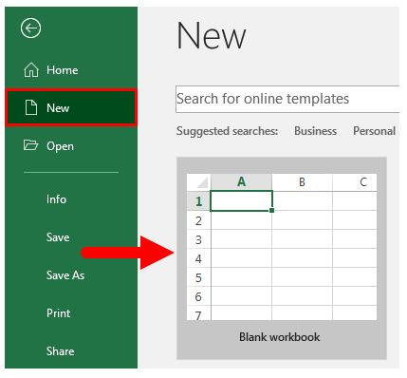
Step 3: By default, Sheet1 will be created as a worksheet in the spreadsheet, and the name of the spreadsheet will be given as Book1 if you are opening it for the first time.
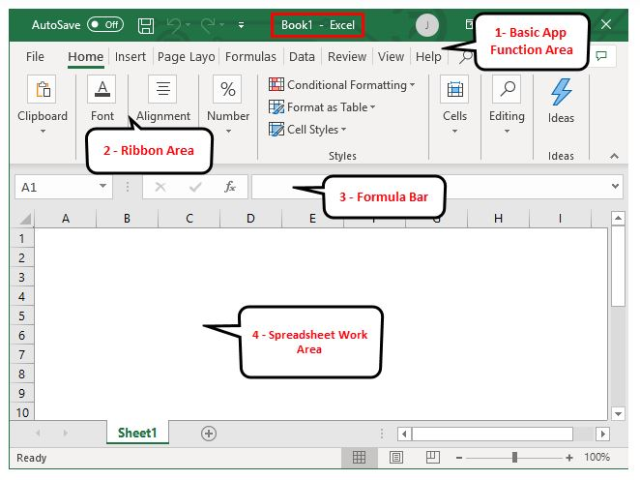
Key Features of the Created Spreadsheet:
- Basic App Functions Area: There is a green banner which contains all type of action to perform on the worksheet like save the file, back or front step move, new, undo, redo and many more.
- Ribbon Area: There is a grey area just below the basic app functions area called Ribbon. It contains data manipulation, data visualizing toolbar, page layout tools, and many more.
- Spreadsheet Work Area: By default, a grid containing alphabetic column A, B, C, …, Z, ZA…, ZZ, ZZA… and rows as Numbers 1,2 3, …. 100, 101, … so on. It is a cell where the user can perform his calculation for personal or business data. Each rectangle box in the spreadsheet is called cell-like selected on the above screenshot is cell A1.
- Formula Bar: It will show the data in the selected cell; if it contains any formula, it will show here. Like the above area, a search bar is available on the top right corner and a sheet tab which is available on the downside of the worksheet. A user can change the name of the sheet name.
Example #2 – How to Create a Simple Budget Spreadsheet in Excel?
Let’s assume a user wants to create a spreadsheet for the calculation of some budget. He has some product and each product sales in each quarter for the year 2018. Now he wants to show this budget to his client.
Let’s see how we can do this with the help of the spreadsheet.
Step 1: Open MS Excel.
Step 2: Go to Menu and select New >> click on the Blank workbook to create a simple worksheet.
OR – Just press Ctrl + N: To create a new spreadsheet.

Step 3: Go to the spreadsheet work area. Which is sheet1.
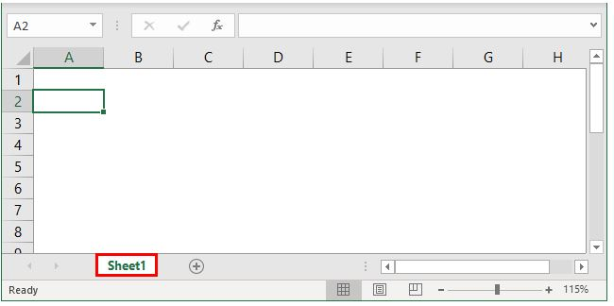
Step 4: Now create headers for Sales in each quarter in the first row by merging cells from B1 to E1, and in row 2, give the product name and each quarter’s name.
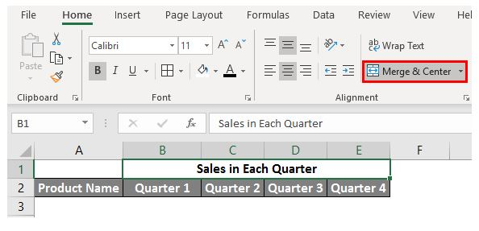
Step 5: Now, write down all product names in column A.
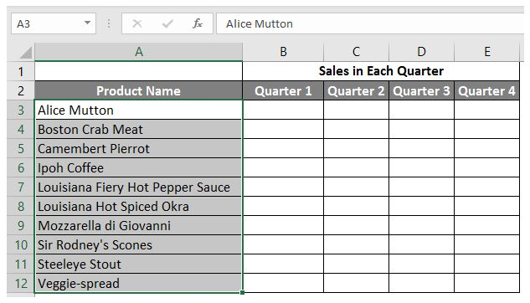
Step 6: Now provide the sales data for each quarter in front of every product.
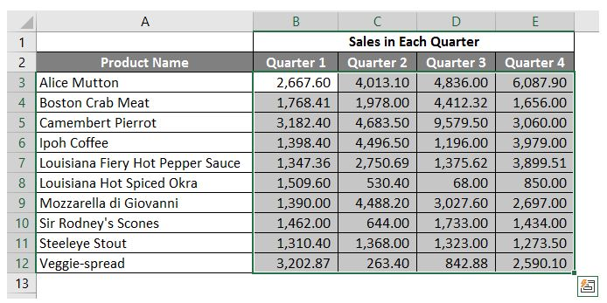
Step 7: Now, in the next row, put one header for Grand Total and calculate each quarter total sales.
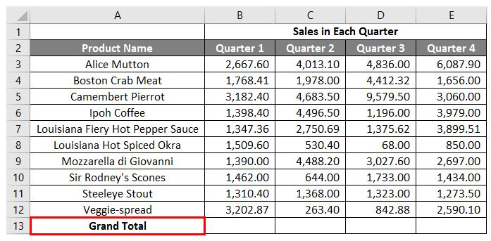
Step 8: Now calculate the grand total for each quarter by summation >> apply in other cells in B13 to E13.
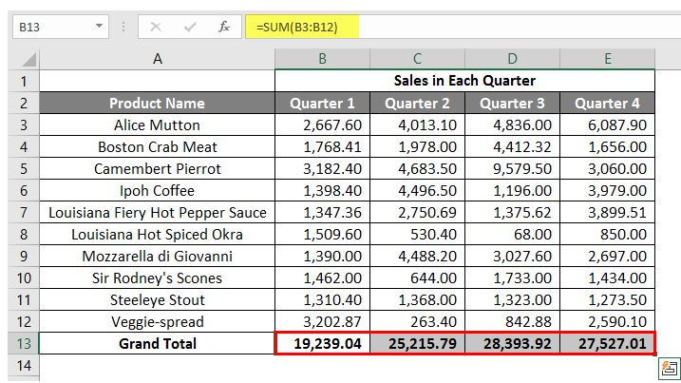
Step 9: So let’s convert the sales value in the ($) currency symbol.
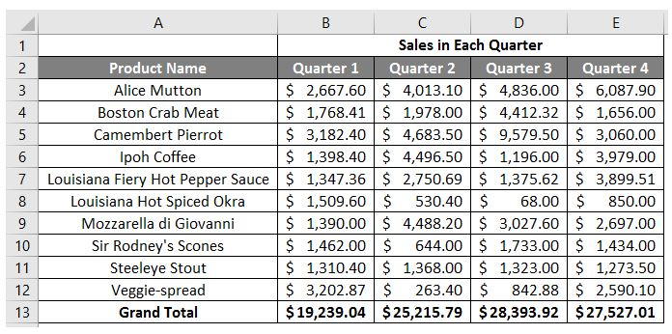

Step 10: Now create a Result Table in which have each quarter total sales.
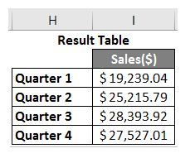
SORT AND FILTER:
Sorting lists
Sorting a list or sorting an entire table are both functions that will most likely come up whenever you are doing data analysis. You can easily sort data in alphabetic, numeric, or even chronological order.
Let us try sorting our table by the ascending alphabetic order of the names of the employees.

Select the range of names in the table. Then in the Home tab, under the Editing group, select Sort A to Z.
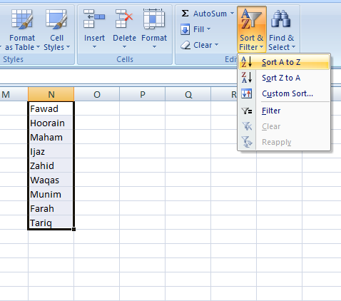

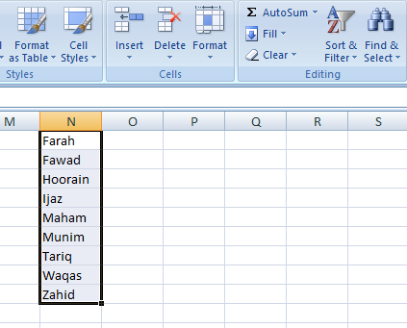

And here you have your sorted list of employee’s names.
FILTERING A LIST

Filtering in Excel allows you to show only the rows of data you are concerned with, and hide all other data temporarily.

One obvious use for filters here is to view the sales information of only a few regions of interest. Let us see how this can be done.
Start by selecting the Region column. Under the Home tab and in the Editing Group, select the Sort and Filter button. Select Filter from the menu.

Notice that there is now an arrow next to the Region header. This arrow means that a filter can be applied to this column, but no filters are currently being used.
Click the arrow next to the Region header. Let us only show the data for sales in the East region. One way to do this is to deselect NW and SW as shown below.

Now, only the rows showing information from either the NE or SE are shown. Notice the button next to the region header has changed to a filter icon indicating that a filter has been applied.

You can perform the same task by creating a Custom AutoFilter as well. Just follow the steps:

After clicking on “Ends With…”, a dialog box will appear for creating a custom AutoFilter:

Click OK, and you have created your Custom AutoFilter successfully.

Lab Tasks
Task # 1:
Create the following spreadsheet in Microsoft Excel and be sure to use formulas to calculate the following:
- The total number of games played under the column labelled GP. The total number of games played can be calculated by adding total wins (W), total losses (L) and total overtime losses (OTL).
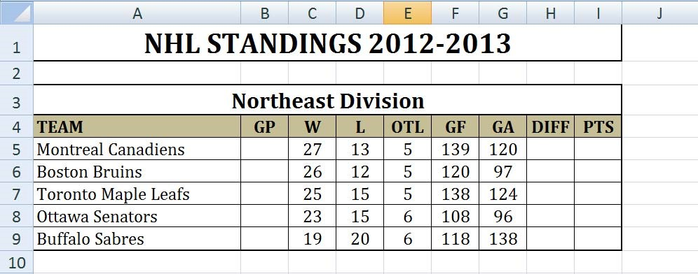
- The goal differential under the column labelled DIFF. The goal differential can be calculated by subtracting the goals for (GF) and the goals against (GA).

Your spreadsheet should look something like this:

Task # 2:
Create the following spreadsheet in Microsoft Excel and be sure to use formulas to calculate the following:
- Each employee’s gross pay under the column labelled GROSS PAY. An employee’s gross pay can be calculated by multiplying the hours worked by the hourly wage.
- The amount of tax paid under the column labelled TAXES. Taxes are calculated by taking 35% of the gross pay.
- The net pay under the column labelled NET PAY, which is calculated by subtracting the taxes from the gross pay.
- The totals of the last three columns (cells D12, E12, and F12).
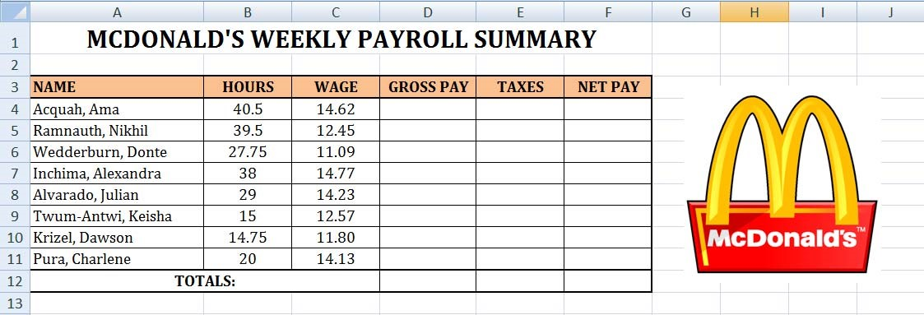
Your spreadsheet should look something like this:

Task #3:
Create the following spreadsheet in Microsoft Excel and be sure to use formulas to calculate the following:
- Each student’s overall average (H3 to H11) by adding the marks on each student’s assignments and tests and dividing it by 6. Be sure to use the AVERAGE function.
- The class average for each assignment and test (B12 to G12).
- The class median for each assignment and test (B13 to G13). Use the MEAN function.
- The highest mark for each assignment and test (B14 to G14). Use the MAX function.
- The lowest mark for each assignment and test (B15 to G15). Use the MIN function.
- The overall class average (H12), the overall class median (H13), the overall highest mark in the class (H14), and the overall lowest mark in the class (H15).
Your spreadsheet should look something like this:
